[Name] Three VPNs/VPN Installation

Hello,

We have researched the following VPN solutions and provided links if further research is required:
- ZeroTier
  - Link: https://www.zerotier.com/platform/
- NetBird
  - Link: https://docs.netbird.io/?_gl=1*1opfkny*_gcl_au*MTk1OTg1MTM1Mi4xNzY2MjYxMjkx
- WireGuard
  - Link: https://www.wireguard.com/

Our research found ZeroTier to be the best of these options due to its minimal administrative overhead, simplicity of setup, and ease-of-use. Furthermore, we successfully installed ZeroTier onto <Name> (IP Address) as per our installation guide on the following page.

Guide:

In order to install a VPN such as ZeroTier on your Linux system, run the following command:

curl -s https://install.zerotier.com | sudo bash

Please note that you do need superuser (sudo) permissions for this command to work. Immediately after running the command, you should see the following output shown in the screenshot below.

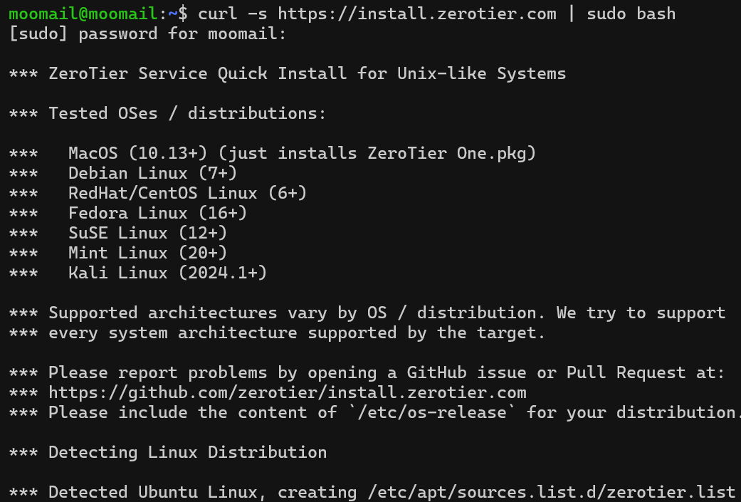

Once the message below is visible, this is confirmation that ZeroTier has successfully been installed and is running.

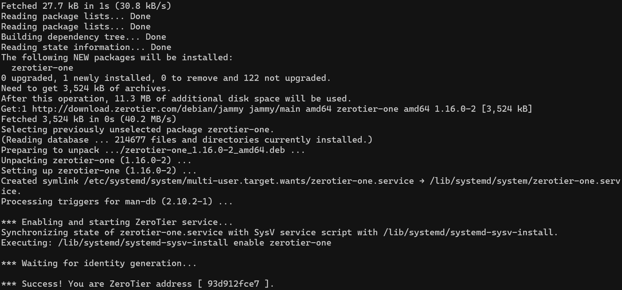

As a final check to verify that ZeroTier is active, run the following command:

systemctl status zerotier-one

You should see the following output.

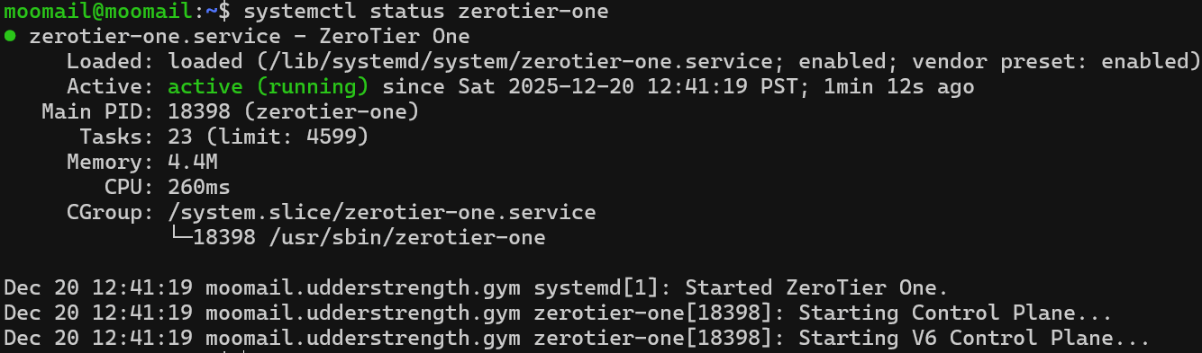

The ZeroTier VPN should now be active and running on your system!

References: https://www.zerotier.com/download/#:~:text=curl%20%2Ds%20https%3A%2F%2Finstall%2Ezerotier%2Ecom%20%7C%20sudo%20bash

We sincerely apologize for the lack of detailed information. Please let us know if we can assist you further in any way.

Best regards,
Team [Team Number]

